TUGAS KONSEP JARINGAN
TUGAS KE – 2 Network Layer



Nama
NRP
Dosen Pengajar
: Shevanka Bagus Dwiyudi Kurniawan
: 3125600044
: Dr. Ferry Astika Saputra, ST, M.Sc

PROGRAM STUDI D4 TEKNIK INFORMATIKA
POLITEKNIK ELEKTRONIKA NEGERI SURABAYA (PENS)
TAHUN 2026
- Tugas Bab 2
- Buat python visualisasi harmonisa spektrum dari sign wave dengan slider
1, 3, 5, 7, 9, 10!
- Analisa IP berikut ke dalam bentuk : Kelas, Network address dan host address, IP pertama, IP terakhir, dan IP broadcast :
  - 21.26.8.5
  - 212.68.3 (Diasumsikan 212.68.3.0)
  - 103.24.56.32
  - 1.1.1.1
  - 172.31.16.8

- Jawaban Bab 2
- Visualisasi Harmonisa Fourier (Python)
import matplotlib.pyplot as plt
from matplotlib.widgets import Slider
import numpy as np

# Parameter sinyal dasar
f0 = 1.0 # Frekuensi fundamental dalam Hz
t = np.linspace(0, 2, 1000) # Rentang waktu 2 detik
allowed_harmonics = list(range(1, 26, 2))

fig, (ax_time, ax_freq) = plt.subplots(2, 1, figsize=(9, 7))
plt.subplots_adjust(left=0.1, bottom=0.22, hspace=0.4)

def compute_fourier_series(max_h):
# Gelombang kotak dibentuk oleh harmonisa ganjil: sum((4 / (pi * n)) * sin(2 * pi * n * f0 * t))
wave = np.zeros_like(t)
all_n = np.arange(1, 26)
amplitudes = np.zeros(25)

for n in range(1, max_h + 1):
if n % 2 != 0:
amp = 4 / (np.pi * n)
wave += amp * np.sin(2 * np.pi * n * f0 * t)
amplitudes[n - 1] = amp
else:
amplitudes[n - 1] = 0.0

return wave, all_n, amplitudes

# Tampilan awal pada harmonisa n = 1
initial_h = 1
wave, harms, amps = compute_fourier_series(initial_h)

(line_time,) = ax_time.plot(
t, wave, color='royalblue', lw=2, label='Sinyal Sintesis'
)
ax_time.axhline(0, color='gray', linestyle='--', alpha=0.5)
ax_time.set_ylim(-1.5, 1.5)
ax_time.set_title(f'Domain Waktu: Sintesis Menuju Gelombang Kotak (n = {initial_h})')
ax_time.set_xlabel('Waktu (detik)')
ax_time.set_ylabel('Amplitudo')
ax_time.grid(True, linestyle=':', alpha=0.6)
ax_time.legend(loc='upper right')

bars = ax_freq.bar(harms, amps, color='crimson', width=0.5, edgecolor='black')
ax_freq.set_ylim(0, 1.5)
ax_freq.set_xticks(harms)
ax_freq.set_title('Domain Frekuensi: Spektrum Amplitudo Tiap Harmonisa')
ax_freq.set_xlabel('Harmonisa ke-n')
ax_freq.set_ylabel('Amplitudo')
ax_freq.grid(True, axis='y', linestyle=':', alpha=0.6)

# Penggeser interaktif
slider_ax = plt.axes([0.15, 0.08, 0.7, 0.04])
slider = Slider(
slider_ax,
'Harmonisa',
valmin=1,
valmax=25,
valinit=initial_h,
valstep=allowed_harmonics,
)

def update(val):
current_h = int(slider.val)
new_wave, _, new_amps = compute_fourier_series(current_h)

line_time.set_ydata(new_wave)
ax_time.set_title(
f'Domain Waktu: Sintesis Menuju Gelombang Kotak (n = {current_h})'
)

for bar, amp in zip(bars, new_amps):
bar.set_height(amp)

fig.canvas.draw_idle()

slider.on_changed(update)
plt.show()

Output :
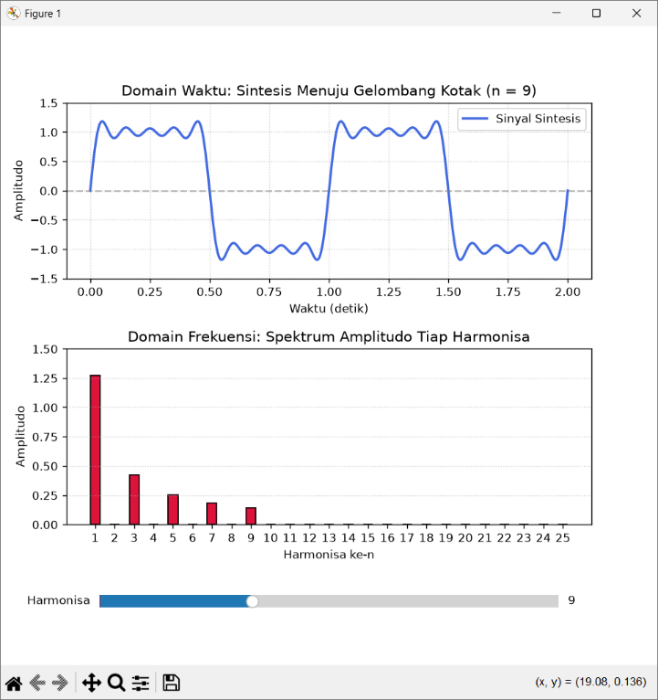
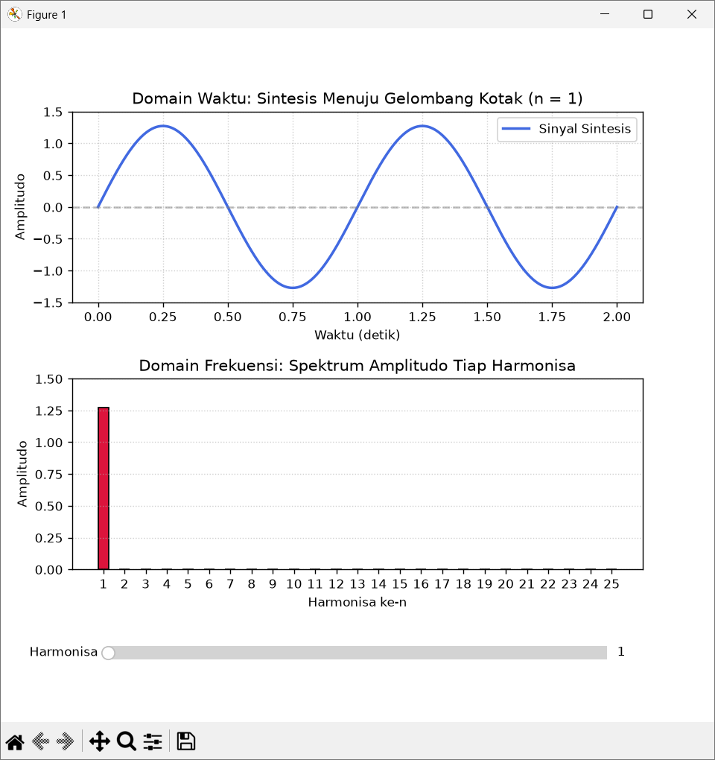

- Analisis Alamat IP
Alamat IP Input | Kelas | Network Address | Host Address | IP Host Pertama | IP Host Terakhir | IP Broadcast
21.26.8.5 | A | 21.0.0.0 | 26.8.5 | 21.0.0.1 | 21.255.255.254 | 21.255.255.255
212.68.3.0* | C | 212.68.3.0 | 0 | 212.68.3.1 | 212.68.3.254 | 212.68.3.255
103.24.56.32 | A | 103.0.0.0 | 24.56.32 | 103.0.0.1 | 103.255.255.254 | 103.255.255.255
1.1.1.1 | A | 1.0.0.0 | 1.1.1 | 1.0.0.1 | 1.255.255.254 | 1.255.255.255
172.31.16.8 | B | 172.31.0.0 | 16.8 | 172.31.0.1 | 172.31.255.254 | 172.31.255.255

